**Bayer Pattern Sensors**

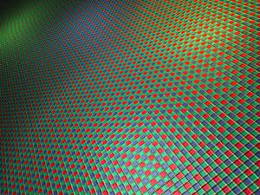

***insert figure 2-13***

Caption: Figure 2-13 Bayer Pattern Color Filter Array

Digital motion picture camera sensor design has moved away from CCD (Charge Coupled Device) technology to CMOS (Complimentary Metal Oxide Semiconductor) technology, partly because of improvements in CMOS capabilities, and partly because of the cost to manufacture. The Bayer pattern mosaic sensor employs a color filter array pattern for arranging *non co-sited* (side by side) RGB color filters over a square grid of adjacent photo sensors on a monoplanar chip. CMOS’ particular arrangement of color filters is used in most single-chip sensors in digital motion picture cameras, camcorders, and scanners to create a color image. This filter pattern is composed of 50% green, 25% red and 25% blue photosites, and is also frequently called RGGB, GRGB or RGGB based on a repeating 2x2 pattern which begins at the upper left hand side. There are 2 green photosites for each red and blue photosite. Because green is the source channel for luminance in digital pictures, this color ratio makes sense in the design of a single plane sensor. This pattern constitutes an orthogonal sampling lattice, with photosite order numbering from left to right, top to bottom. There are many other color filter array patterns and sensor types in use for other purposes in other devices, but for now we will limit the discussion to the patterns and sensor types most commonly used in digital cinema cameras.

**Courtesy of Mitch Bogdanowicz and Jim Bogdanowicz**

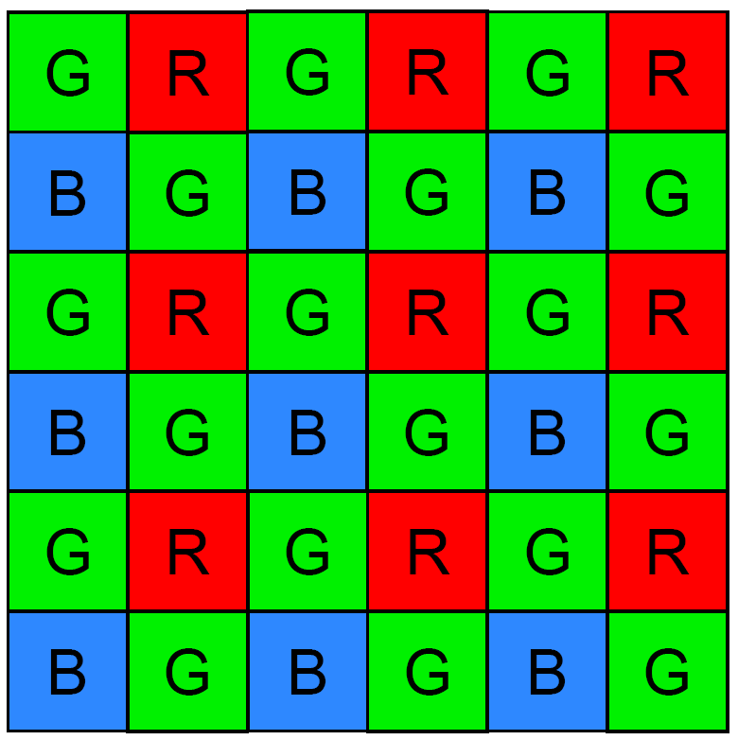

***insert figure 2-14***

Caption: Figure 2-14 Bayer Pattern Color Filter Array

Because of the human visual system, a minimum of three color planes are required to represent a full color digital image. The spectral response of these planes usually corresponds to the sensitivities of cones in the human eye.

A typical camera sensor detects light intensity but no color information. Most digital cinema cameras use a single light sensor together with a color filter array (CFA). The CFA allows only one color of light to reach the sensor at each photosite. The result is a mosaic image, where a photosite location captures either red, green or blue light. The Bayer Pattern is the most commonly used CFA design. (B. E. Bayer, "Color imaging array", U.S. Patent 3,971,065, 1976.)

**Courtesy of Mitch Bogdanowicz and Jim Bogdanowicz**

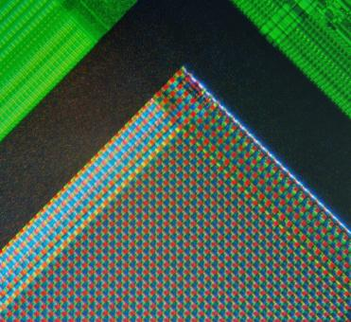

***insert figure 2-15***

Caption: Figure 2-15 Closeup View of a Bayer Pattern Sensor

The convenience of this single chip sensor method of gathering images comes with a price. A Bayer pattern array lays out a red, a blue, and (usually) two green photosites side by side in offset rows to achieve an average color and luminance sample of the image. Because all three colors are recorded by separate and non-co-sited photosites, the resulting images initially contain color sampling errors that result from the difference between the light sampled or not sampled by each photosite.

To reiterate, the light falling on a Bayer pattern array is largely wasted. A green photosite can only collect the green light that falls on it, red and blue light are blocked. A red photosite can only collect the red light that falls on it, green and blue are rejected, and a blue photosite can only collect the blue light that falls on it, rejecting red and green light.

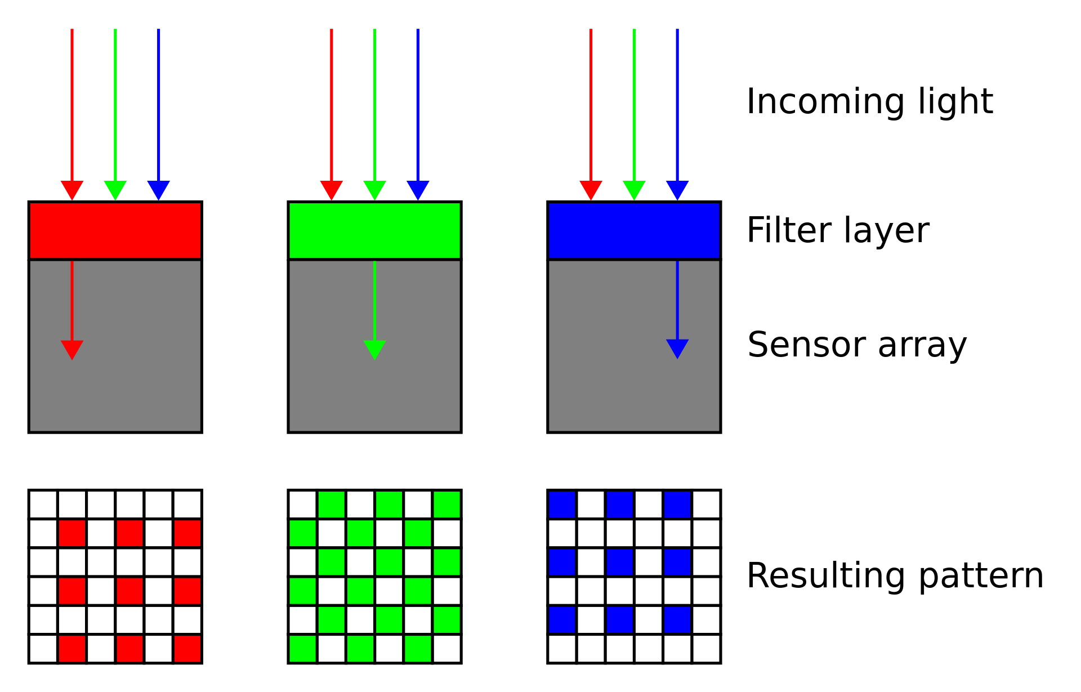

***insert figure 2-16***

Caption: Figure 2-16 Filtered Red Green and Blue Light Landing on Non Cosited Photosites

The white squares in each color record represent sites where there is no color information. Values will be synthesized and assigned to those areas by a process of interpolation. A Bayer pattern sensor discretely samples and records each of the three primary colors from adjacent photosites for use in later interpolating RGB color for areas of photosites on the sensor with the assistance of its neighboring photosites. These *photosites* are not yet tricolor *RGB pixels*.

**RAW File Formats**

A camera RAW image file contains minimally processed image data from a Bayer pattern image sensor in a digital motion picture camera. RAW files are not yet ready to be viewed or edited until the image is processed by a RAW converter into a usable image file format. There are dozens of raw formats in use by different manufacturers of digital image capture equipment.

A RAW digital image usually holds a wider dynamic range and color gamut than the resulting deBayered frame it will parent, the purpose of RAW image formats is to save, with minimum loss, the data obtained from the sensor. Raw image formats are intended to capture the scene referred radiometric characteristics of the scene, the physical information about the light intensity and color of the scene, at the highest level of the camera sensor's performance.

RAW files contain a file header which conveys the byte ordering of the file, a file identifier and an offset into the main file data, camera sensor size and color profile map of the Bayer pattern Color Filter Array (CFA) required to assign discreet colors to the sensor image data. They also contain image metadata required including exposure settings, camera and lens model, date, time and place, authoring information and an image thumbnail, (a JPEG or other temp conversion of the image), which is used to view the file on the camera's viewfinder.

**DeBayering (De Mosaicing) RAW Bayer Pattern Images**

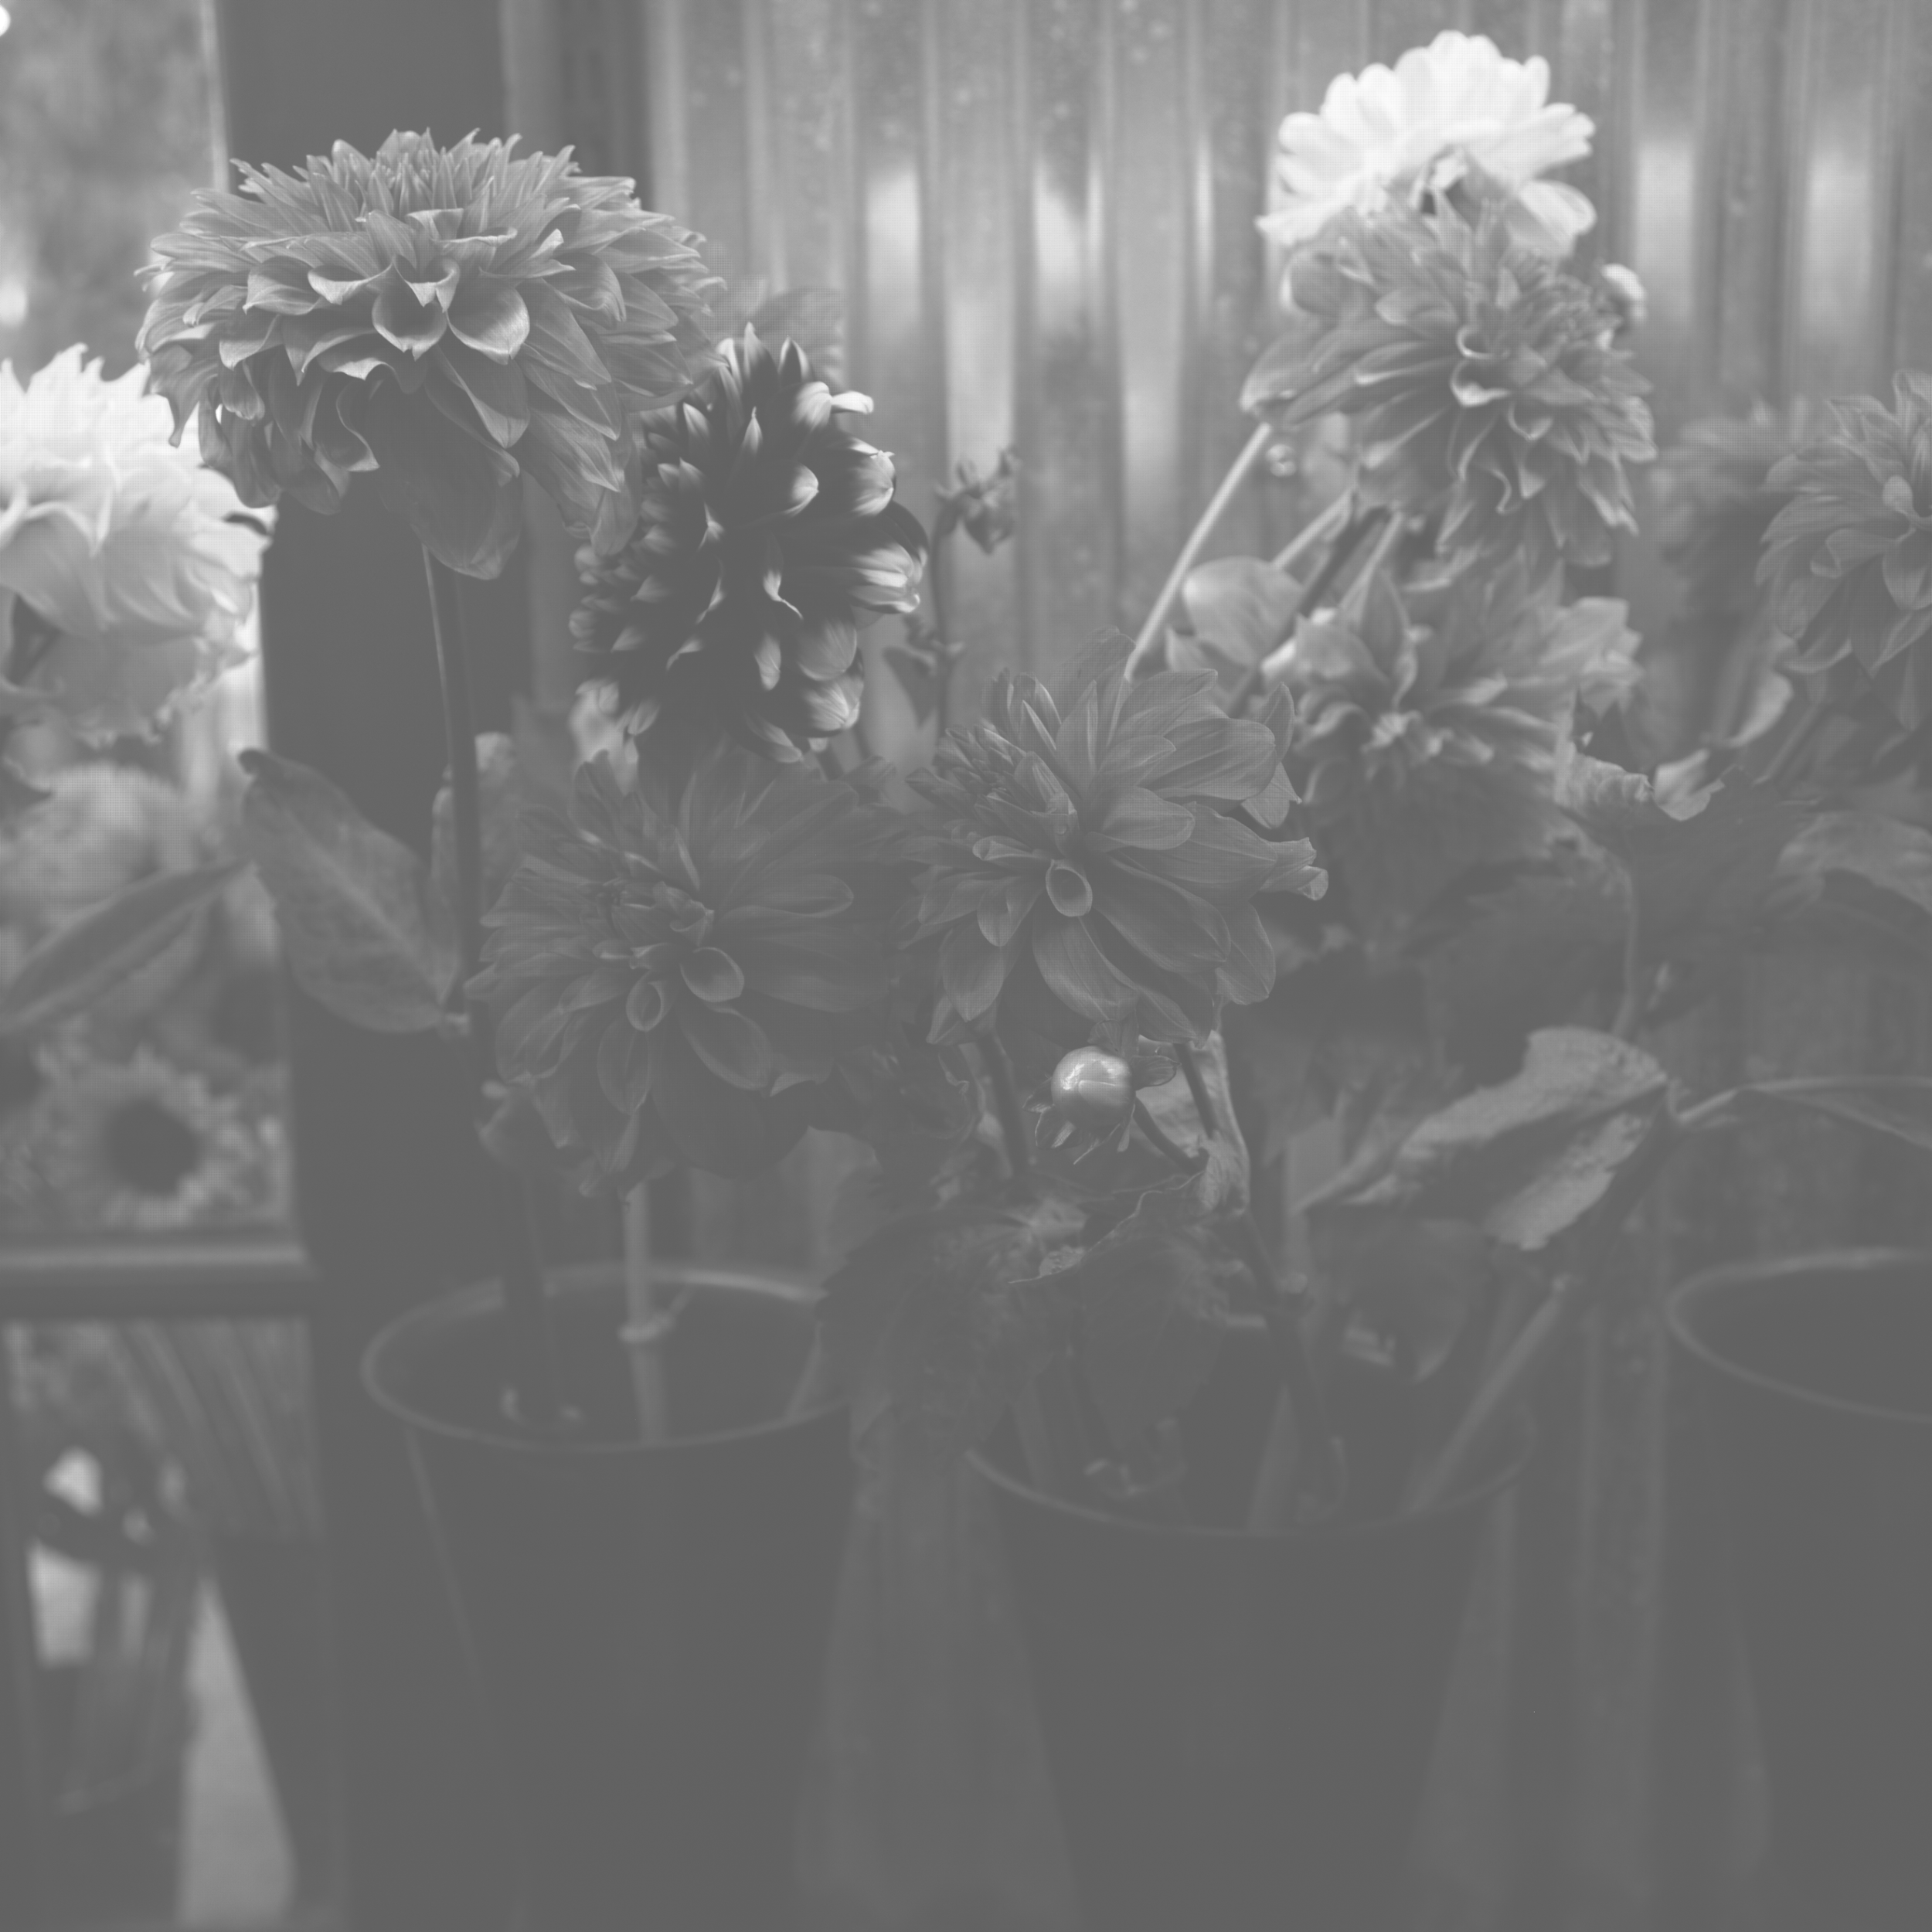

***insert figure 2-17***

Caption: Figure 2-17 A Typical monochrome RAW Bayer Pattern Image before color assignment

Photosites in this Bayer Pattern arrangement cannot be said to be pixels, as they only carry RAW monochrome tonal values until they are assigned colors in either Red only, Green only or Blue only, corresponding to the dye color covering each individual photosite. Once each photosite has been told whether it is a red, green or blue photosite, the image then consists of discrete Red only, Blue only and Green only values, which looks like this;

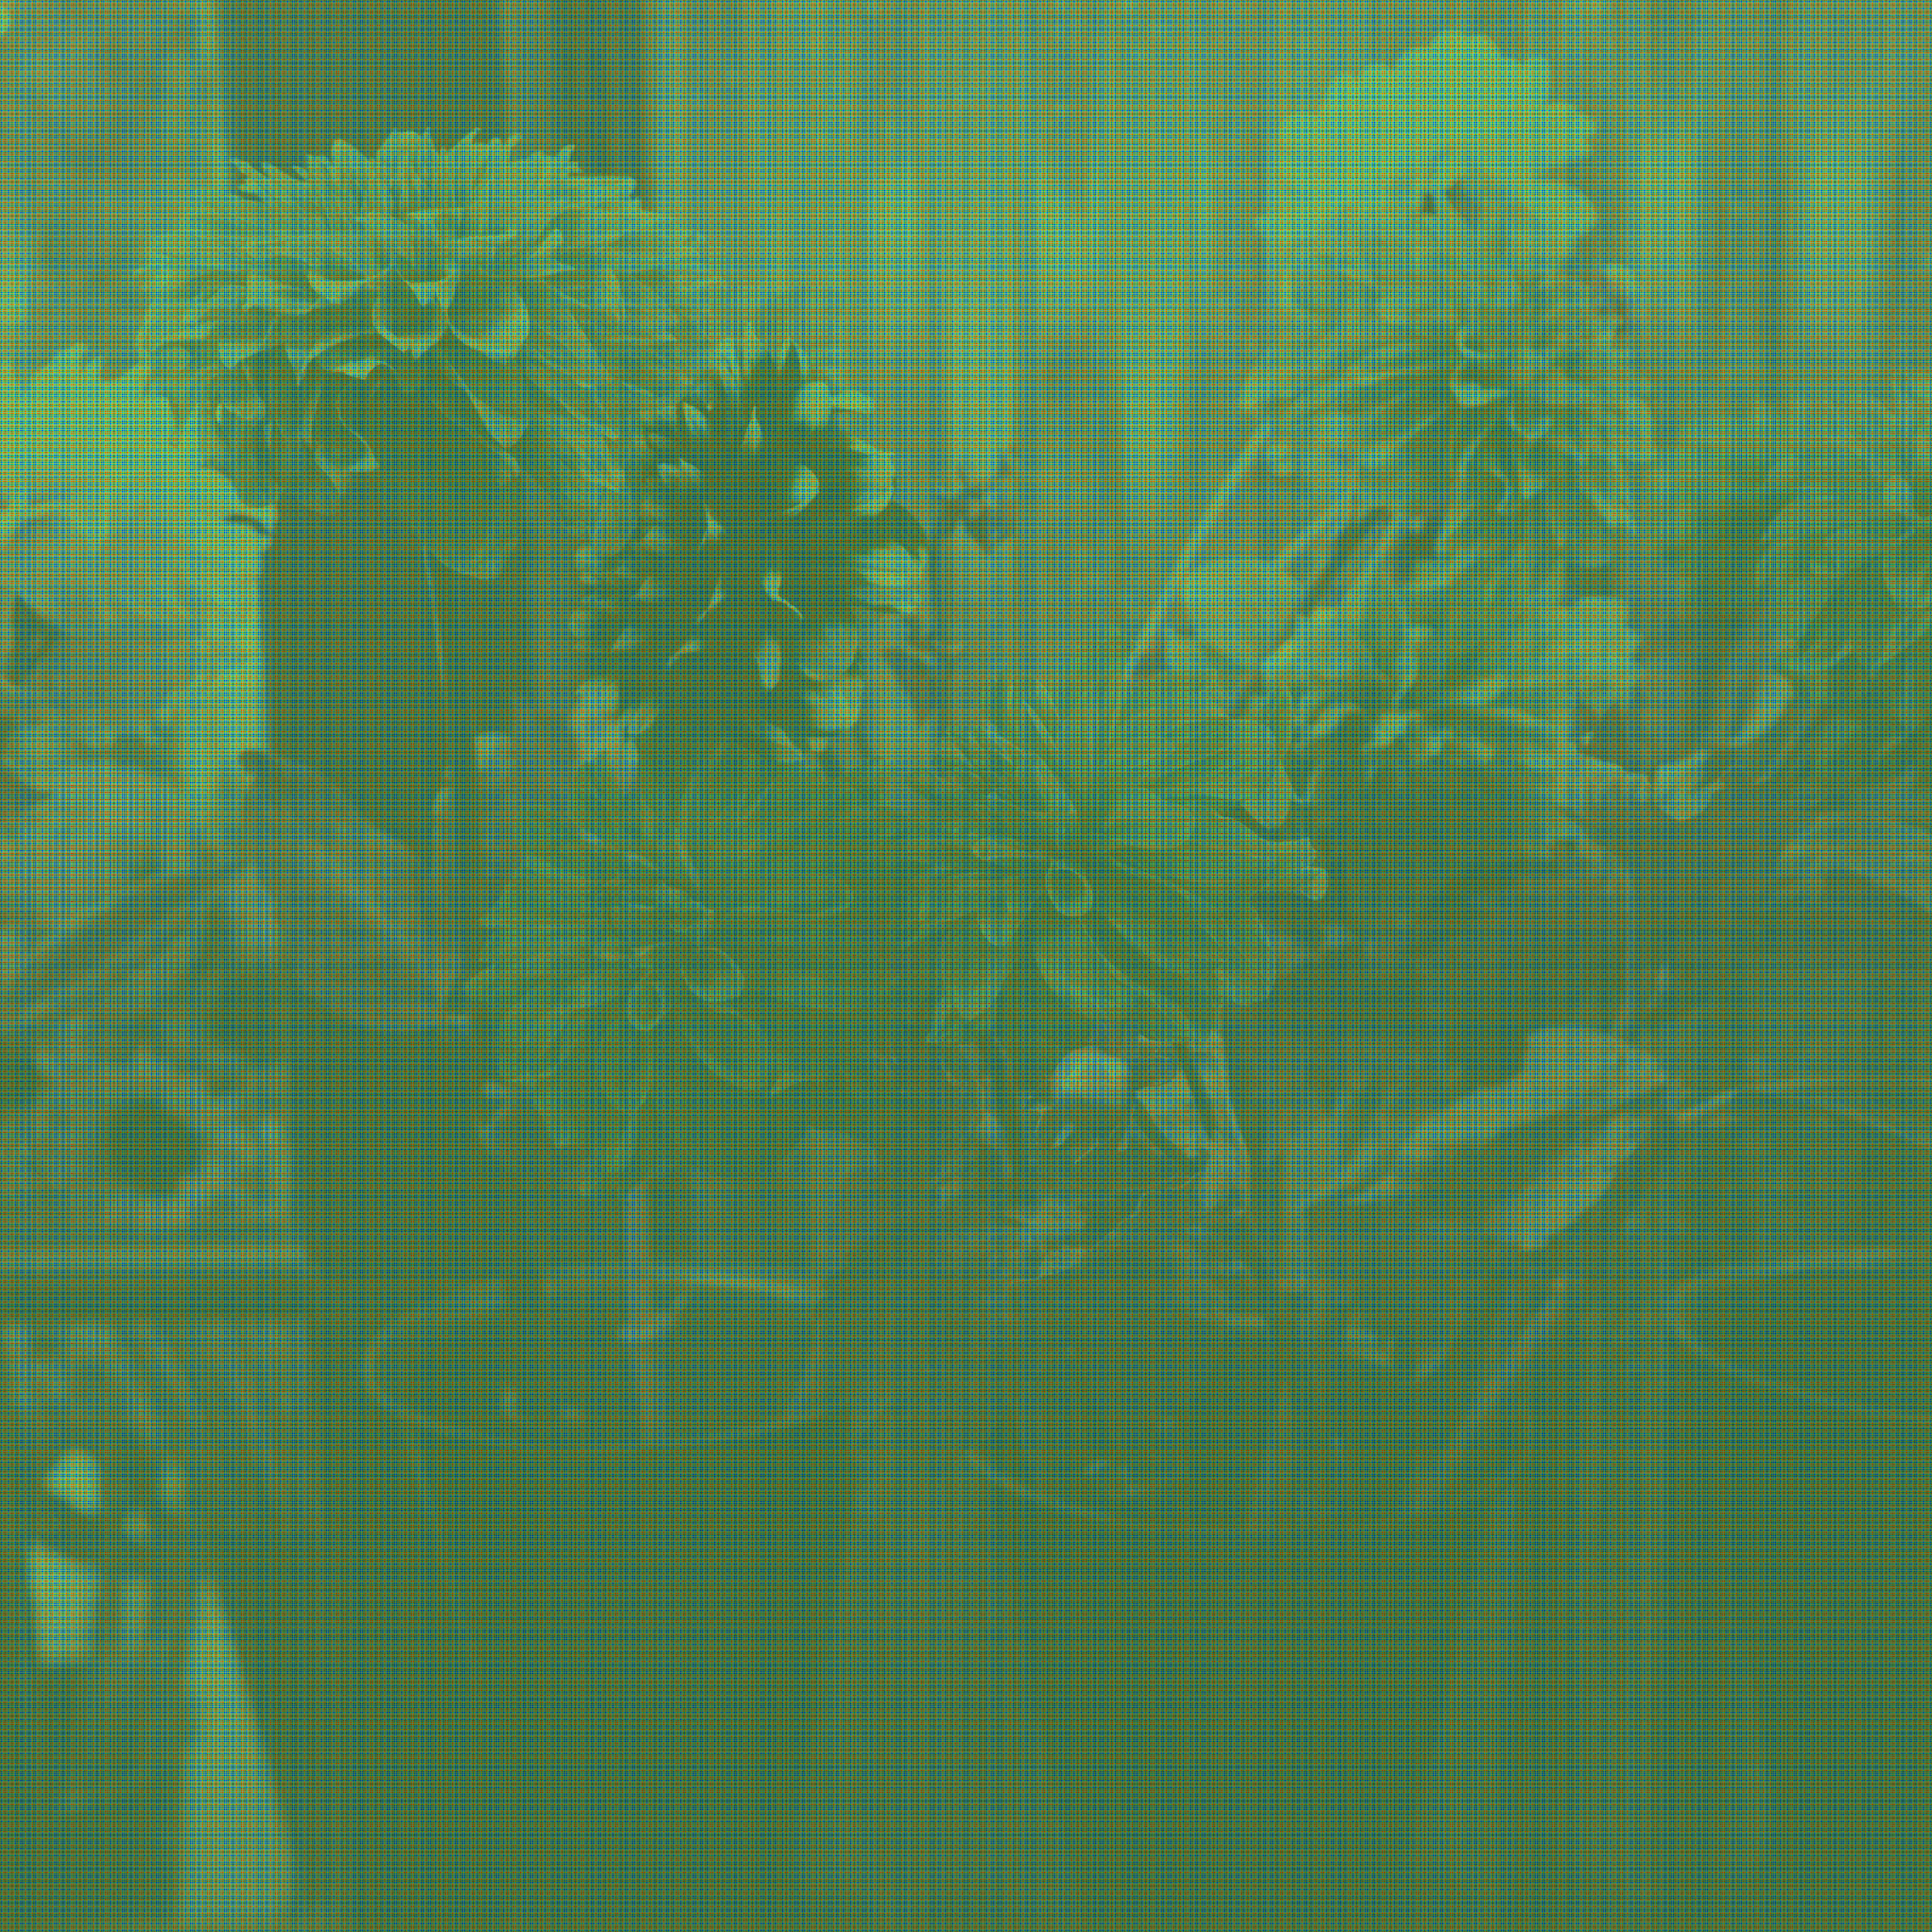 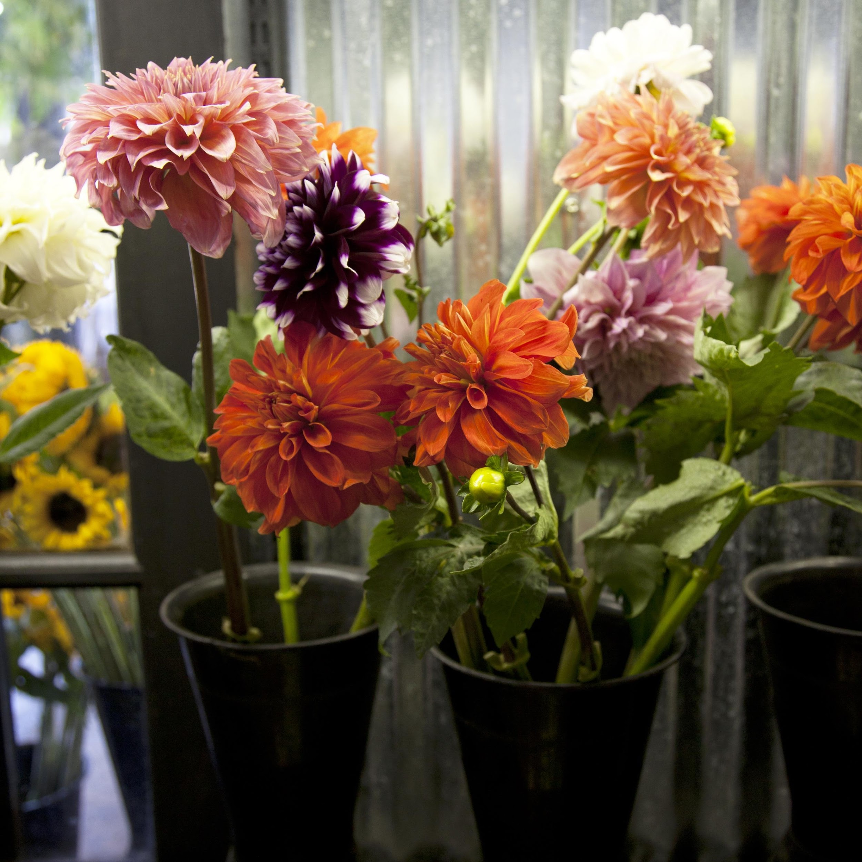

***insert figure 2-18***

Caption: Figure 2-18 RGB assigned Bayer Image Before de-Bayering

***insert figure 2-19***

Caption: Figure 2-19 The Same Image After de-Bayering (side by side)

The process of “de-Bayering” interprets from adjacent discreet Red or Green or Blue photosites to create RGB pixels that attempt to accurately reconstruct the scene. We will learn more about this process.

If we take a closer look at the image we can gain some insight into the imaging process before and after de-Bayering.

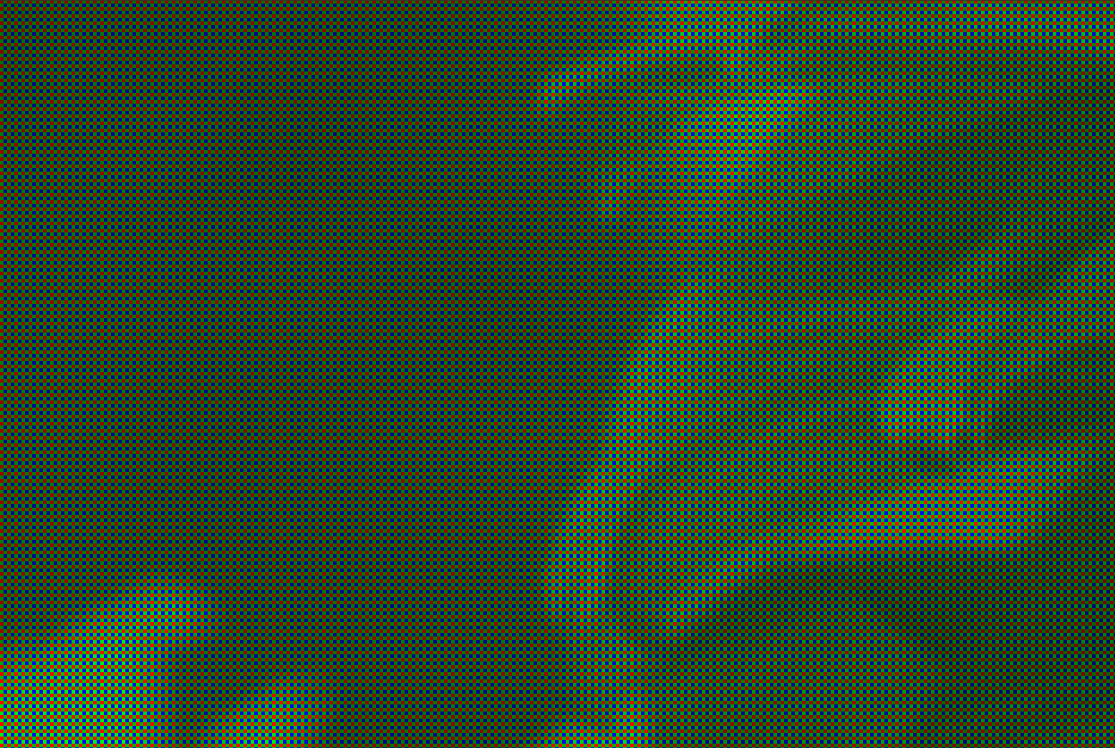 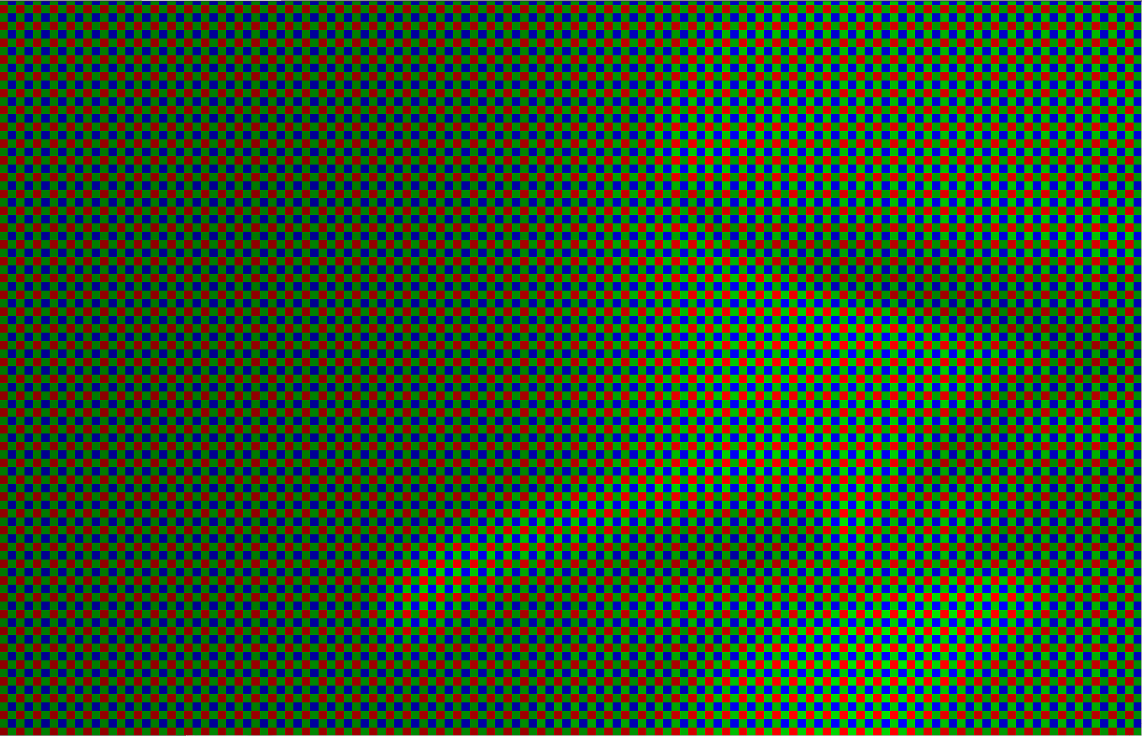

***insert figure 2-20***

Caption: Figure 2-20 Bayer Image (not yet de-Bayered)

***insert figure 2-21***

Caption: Figure 2-21 Bayer Image Magnified (side by side)

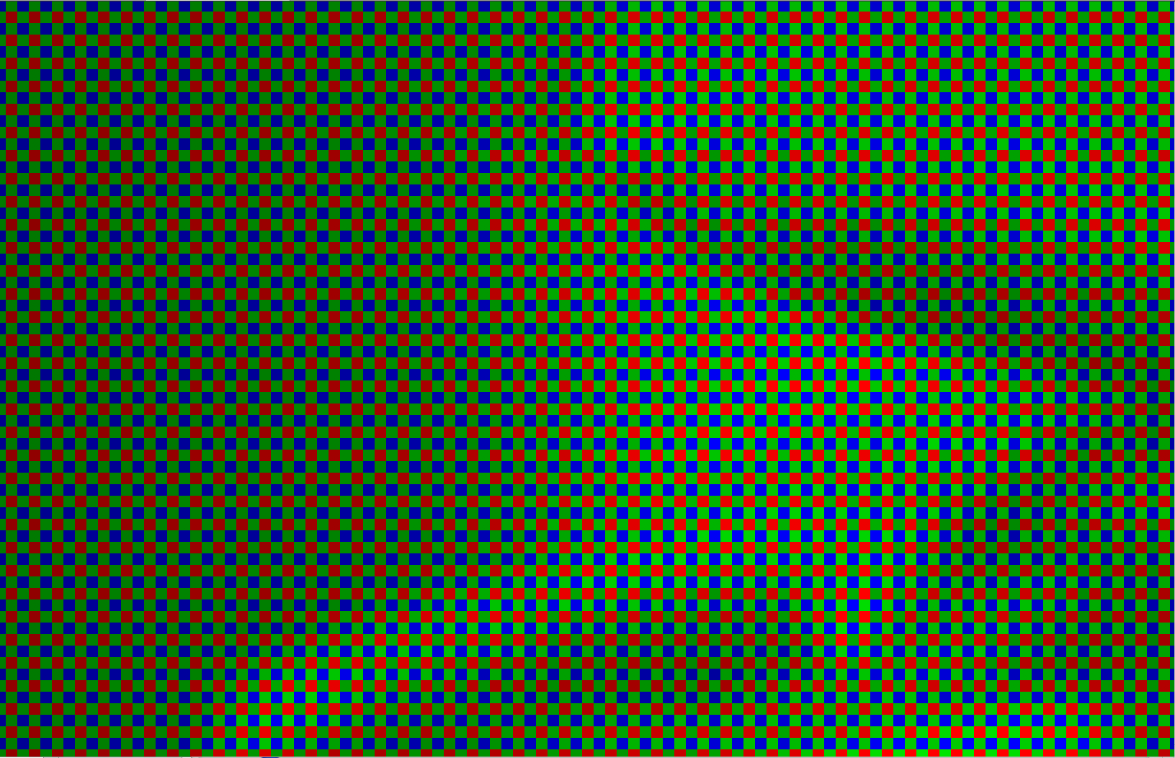

***insert figure 2-22***

Caption: Figure 2-22 Very Close on a Bayer Pattern Image Before de-Bayering

Close examination of the image reveals that it is still constructed of individual photosites values that all fall on either a Red tonal scale, a Green tonal scale or a Blue tonal scale.

None of the camera original photosites yet contains full RGB information; as a result, their digital code values can be stored as a value 1/3 the size of an RGB pixel. Raw images are generally about 1/3 the size of RGB images.

The process of de mosaicking these images is called deBayering, a mathematical operation that interpolates the missing color data for each photosite in the array from surrounding known data in order to synthesize full color RGB pixels to form a debayered image which may or may not have the same spatial resolution as the original un deBayered image.

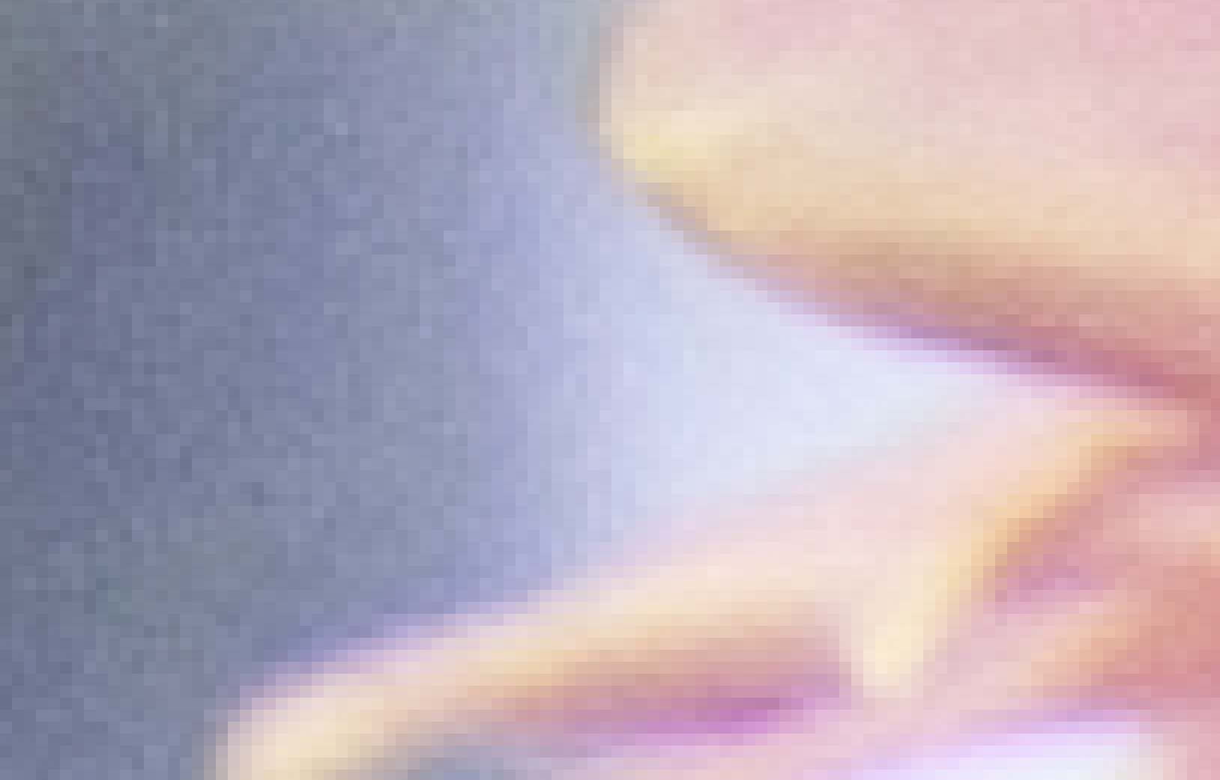

***insert figure 2-23***

Caption: Figure 2-23 The Same Image After de-Bayering

**De Bayering Algorithms**

A variety of deBayer reconstruction processes are used to mathematically generate and assign full color RGB values to all of these single color value photosites based on color information shared and interpreted from neighboring photosites. There are numerous mathematical algorithms for interpolating missing color information for red only, blue only and green only photosites, and each algorithms can deliver different aesthetic results. I will summarize a few (of the many) here.

**Nearest Neighbor**

The simplest of all interpolation algorithms is a nearest neighbor interpolation. Using a 2x2 neighborhood from the Bayer pattern, missing color values are interpolated by simply adopting the nearest sampled value.

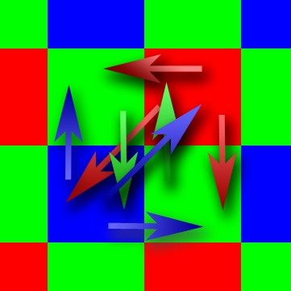

***insert figure 2-24***

Caption: Figure 2-24 “Nearest Neighbor” DeBayering

The sampled blue and red values in a 2x2 neighborhood are used at the three remaining locations. The sampled green values can be shared in either a vertical or horizontal direction to fill in color values for the photosites without green information.

**Bilinear Interpolation**

Another simple interpolation algorithm is bilinear interpolation. A 3x3 neighborhood is taken from the CFA and missing pixel values are calculated by averaging nearby values.

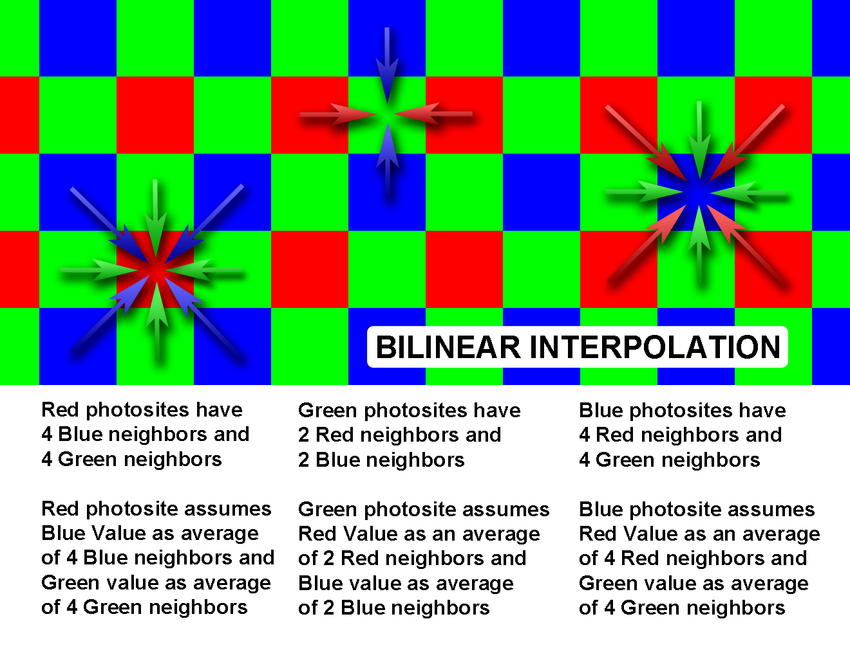

***insert figure 2-25***

Caption: Figure 2-25 How Bilinear “de-Bayering” Works

This interpolation method performs well in smooth areas where the colors change slowly from one to the next. When utilized along edges where color changes occur abruptly, false color and zipper artifacts are introduced, sometimes resulting in a poor image quality.

From Mitch and Jim Bogdonowicz

The simplest demosaicing methods interpolate each color channel separately. One such technique is bilinear interpolation, which uses the average of the surrounding pixels. In bilinear interpolation, each missing green value is calculated as the average of the four surrounding green values, and each missing red or blue value is calculated as the average of the two nearest neighbors or four nearest neighbors, depending on the position relative to the edge. Other standard interpolation methods, such as cubic spline interpolation, can be used to slightly improve the performance when processing each color channel separately.

The problem with methods that interpolate the color channels independently is that they usually fail at sharp edges in images, resulting in objectionable color artifacts.

To minimize the problems caused by simple channel independent methods that interpolate the color planes separately, adaptive demosaicing algorithms have been developed which utilize the correlation between the color channels.

Advanced demosaicing algorithms put a lot of computational effort into reconstructing high frequency detail in the red and blue color channels. If the image is compressed afterwards, it will often be converted to YCbCr 4:2:0 format. In this format, the chroma channels (Cb, Cr) are down-sampled by a factor of two in both the horizontal and vertical directions, resulting in a loss of the high frequency color information.

From Mitch and Jim Bogdonowicz

**Cubic Interpolation**

Cubic interpolation is similar in nature to linear interpolation. Cubic interpolation suffers from the same artifacts as linear interpolation, but to a lesser degree. The expanded 7x7 neighborhood reduces the appearance of these artifacts, but they are still present in the final image.

**High Quality Linear Interpolation**

High Quality Linear Interpolation improves linear interpolation by exploiting interchannel correlations between the different color channels. A 5x5 neighborhood is used, wherein the nearby pixels of the corresponding color channel are averaged and then added to a correction term calculated from information in a different color channel. Despite a modest increase in the number of computations performed compared to the linear and cubic interpolations, this method outperforms many more complicated, nonlinear methods, with greatly reduced edge artifacts.

**Smooth Hue Transition Interpolation**

The key assumption of High Quality Linear Interpolation is that hue is smoothly changing across an object’s surface. The false color artifacts of linear and other methods of interpolation result when hue changes abruptly, such as near an edge. In this case, hue is defined as the ratio between color channels, in particular the ratio between red/blue and green.

**Pattern Recognition Interpolation**

Thus far, all of the interpolation algorithms cited thus far have flaws estimating colors on or around edges. In attempt to counteract this defect, Pattern Recognition Interpolation describes a way to classify and interpolate three different edge types in the green color plane. Once the green plane is interpolated, the red and blue color planes are interpolated using the smooth hue transition interpolation described previously. The first step in this procedure is to find the average of the four neighboring green pixels, and classify the neighbors as either high or low in comparison to this average. This pixel is then defined as an edge if three neighbor pixels share the same classification. If not, then the pixel can either be a part of a corner or a stripe. If two adjacent neighbor pixels have the same classification, then the pixel is a corner. If two opposite pixels have the same classification, then the pixel is a stripe.

**Adaptive Color Plane Interpolation**

Up to this point, the interpolation of the green color plane has occurred using only information from the green samples from the CFA data. However, certain assumptions can be made regarding the correlation between the color planes. One well-known assumption is that the color planes are perfectly correlated in a small enough neighborhood. It works well to interpolate missing pixel values along edges, rather than across them. In order to utilize the edge detection capability of adaptive color plane deBayering, it is useful to consider many directions. In some methods, as many as 12 directions are considered in which all the G information in a 5x5 neighborhood is used.

**Resolution in Bayer Pattern Cameras**

It is a bit disingenuous to cite a cameras resolution as the resolution of the final image created demosaicing. The deBayering process is a process of *averaging* color values across the sensor, and decimation of resolution is inherent in that averaging. It is NOT accurate to cite the resolution of a sensor as the number of photosites. Photosites are NOT RGB pixels. The real world resulting effective resolution of deBayered images depends on the deBayer algorithm used. For this reason, it makes little sense to assess a Bayer Pattern Camera’s resolution in terms of photosite count. Any given deBayer algorithm can produce the same number of RGB pixels from the same original raw image, so the real question is what is the efficiency of the deBayer algorithm employed in terms of resolution delivered?

Depending on the deBayer math used, the resulting color information can vary in real world measurable spatial resolution, most often less than the photosite count of the sensor. Depending on the math used, the effective output spatial resolution can be expressed as a percentage of the Bayer sensor photosite count. The most widely used methods of de-Bayering usually result in from 66% to 90% of the photosite count of the sensor, and higher with some algorithms. It is possible to deBayer to higher pixel counts, but the methods that result in higher measurable real world spatial resolution are very mathematically intensive, usually not real-time. There is no direct correspondence between the number of photosites on a sensor and the number of pixels in a debayered image, and there is most often less effective resolution in debayered images because as color is averaged, so is resolution.

**Converting Raw Images to RGB Images**

Lars Borg on Converting Raw Images to RGB;

Converting a raw image to an RGB image takes a fair amount of image processing. It includes much more than just de-Bayering. This processing also bakes in a look in the image.

In a video or JPEG workflow, this processing is done entirely in the camera.

In a raw image workflow, most of the image processing is done in post. As post gets the original sensor data, post can apply and reapply different looks without the loss of quality that would occur should you drastically edit a video image in post.

The image processing often includes the following steps in the order shown below:

#### **Dead pixel removal**

The values of dead or stuck photosites are restored through interpolation with the nearest good same-color photosites.

#### **Noise reduction**

Noise reduction is an early stage in the image pipeline. This assures that later non-linear stages produce results that are more predictable without sporadically amplifying the noise. Beware that too much noise reduction can destroy image detail.

#### **Linearization**

The sensor's response to light is rarely truly linear. Many sensors have a soft knee, a slightly reduced sensitivity above 70%. The linearization step restores this to a linear signal.

#### **Black level subtraction**

The signal recorded by unexposed photosites is rarely zero. Non-light sources such as thermal noise and electrical interference within the sensor can generate a small signal.

The average level of this black signal can be calculated and then subtracted from the image. After the subtraction, on average the unexposed photosites will have a value of zero. Due to sensor noise, some photosites may now get negative values. These values must be retained, as clipping to zero can result in visible artifacts such as blotchy shadows.

#### **Demosaic to RGB**

The demosaicing stage restores the RGB image pixels from the color-filtered photosites. Bayer (RG/GB) is the most common layout for the color filter mosaic, but since other color filter layouts are in use, the general name for this process is demosaicing, (often loosely referred to as de-Bayering).

The demosaicing algorithm varies from vendor to vendor, and the most advanced methods are protected by patents or trade secrets.

Here we can only give a sampling of the available algorithms:

**Nearest Neighbor of Same Color**

The very crude nearest neighbor method fills in the missing color values from a nearest photosite of the desired color. While the method is fast, the results are inferior. Sharp edges will show severe color bleed. For Bayer patterns, the effective image resolution is half the photosite resolution, as that's the spacing of the red and blue samples. This method can be acceptable when the image is downsampled to the effective (meaning eventual output) resolution.

**Averaging Same Colors**

A missing color value can be calculated by averaging the colors of the surrounding photosites of the desired color. This method is slower than the nearest neighbor method, and the results usually are slightly better, although edges get jaggies instead of color bleeds. For Bayer patterns, the effective image resolution is yet again half of the photosite resolution. Unfortunately, this method is very common, as it is very easy to implement.

**Using All Photosites**

The better methods use all available colors and photosites for restoring each color. Just like in the eye, the spectral curves of the different color filters are designed to overlap. It is rare to find a color on set that registers in only one set of color filters. And almost all natural objects have wide spectral reflectance curves. The extreme exceptions would be laser lights. Thus, all objects provide details in all photosites, and the advanced methods utilize this using all photosites to calculate each color plane. The effective image resolution is now **the same as** the photosite resolution. As these methods often detect gradients, they may be more sensitive to image noise.

We now have an RGB image in the color space of camera RGB, and we can now apply the processing steps that require RGB pixels.

#### **Lens corrections**

When the lens characteristics, including the focal length for a zoom, are well known, lens artifacts such as barrel distortion and chromatic aberration can be reduced by applying the appropriate geometric counter-distortions.

#### **Cropping**

Next, the image is cropped. The demosaicing methods can produce artifacts in the edge pixels, so these are cropped off. The cropping can also set the desired aspect ratio, such as 2.39:1, 16:9 or 4:3.

#### **Scaling**

The RGB image can be scaled up or down to the desired image-sampling rate, such as 1920 x 1080. This must be done with methods that don't introduce moirés or discard image details. Upsampling will not provide more image detail, but may be needed to fit a specific workflow, such as HD.

#### **White balance**

In the white-balance step, the RGB values read off a gray card are used to scale the RGB channels to equal values for gray. This can be as simple as just dividing with the gray card RGB values, or more advanced, taking into account chromatic adaptation, and applying a matrix.

This step is easily combined with the color conversion step for better overall performance.

This step may also include clipping overexposed pixels to the max neutral value. If not all three channels are clipped, then advanced methods may also try to restore the actual exposure values.

#### **Color conversion**

In this step, the camera RGB values are converted to a more useful RGB color space, such as Rec 709 or ACES. This is commonly done by applying a matrix multiplication.

The matrix needs to include chromatic adaptation, which compensates between the color temperature on set, and the color temperature of the new color space, so that colors look natural in their new color space.

If this image were being prepared to go into a post workflow such as ACES, we would stop here. If instead we were preparing HD footage, the following steps would be applied.

#### **Color enhancements**

Some video and still-camera workflows automatically apply selective color enhancements such as improving skin tones, or sky colors.

#### **Toning curve**

As the world as seen by the camera looks flat, a toning curve is applied to add contrast.

#### **Gamma curve**

If the outgoing data format is gamma encoded, such as Rec 709, a gamma curve is applied.

#### **Clip to fewer bits**

The data up to this stage has often been carried at large bit depth, such as 12, 16, or 32 bits. At this point the least significant excess bits need to be discarded.

#### **Lossy compression**

Finally, a lossy compression may be applied to get down to a target data rate, such as 250 Mbit/s for digital cinema.

**Cinema DNG Format**

Raw image formats were first introduced in the still camera market in the late 1990’s. The combination of high quality raw images and powerful image editors such as Photoshop provided powerful tools for image creation, superior to using JPEG files. By 2007, at least 80% of all professional still photographers shot raw images.

In the early days, every camera vendor created it’s own raw file format. This resulted in a proliferation of multiple file formats for every application to support. In 2011, there were over 150 unique formats. Interestingly the vast majority of these proprietary file formats are actually good old TIFF under the hood, sometimes with proprietary metadata tags such as color encoding.

To stem the tide of proprietary formats, in 2005 Adobe introduced its own raw format, called DNG. Adobe’s DNG (also based on TIFF) eliminated the need for proprietary formats by including a superset of the features found in all of the proprietary raw formats, plus options for more metadata, all fully documented and usable freely, without NDAs or license fees, including a free software library. The DNG format is now used by hundreds of camera and software vendors, excluding only the few camera manufacturers who have a business interest in using their own proprietary formats.

All known raw files can be converted to DNG without loss of data, and many publishers convert their various raw files to DNG for archiving to assure that the images will be readable in the future when the original camera format is eventually abandoned.

A few years after the digital revolution changed the nature of still photography, the digital cinema market went through the same turmoil. At one point, there were over 60 different raw formats, a large number of those coming from a single camera manufacturer. A group of camera and software vendors realized where the proliferation of proprietary formats was leading, and at NAB in 2008, under the leadership of Adobe, the Cinema DNG initiative was formed. The Cinema DNG format is DNG extended with metadata unique to motion picture production (such as time code).

Attribute Lars Borg, Senior Color Scientist, Adobe